AIR QUALITY MONITORING

PROGRAM

from machine import Pin

from time import sleep

import dht

import network

sta_if = network.WLAN(network.STA_IF)

if not sta_if.isconnected():

    print('connecting to network...')

    sta_if.active(True)

    sta_if.connect('Wokwi-GUEST', "")

    while not sta_if.isconnected():

        pass

    print('network config:', sta_if.ifconfig())

sensor = dht.DHT22(Pin(15))

while True:

  try:

    sleep(2)

    sensor.measure()

    temp = sensor.temperature()

    hum = sensor.humidity()

    temp_f = temp * (9/5) + 32.0

    print('Temperature: %3.1f C' %temp)

    print('Temperature: %3.1f F' %temp_f)

    print('Humidity: %3.1f %%' %hum)

  except OSError as e:

    print('Failed to read sensor.')

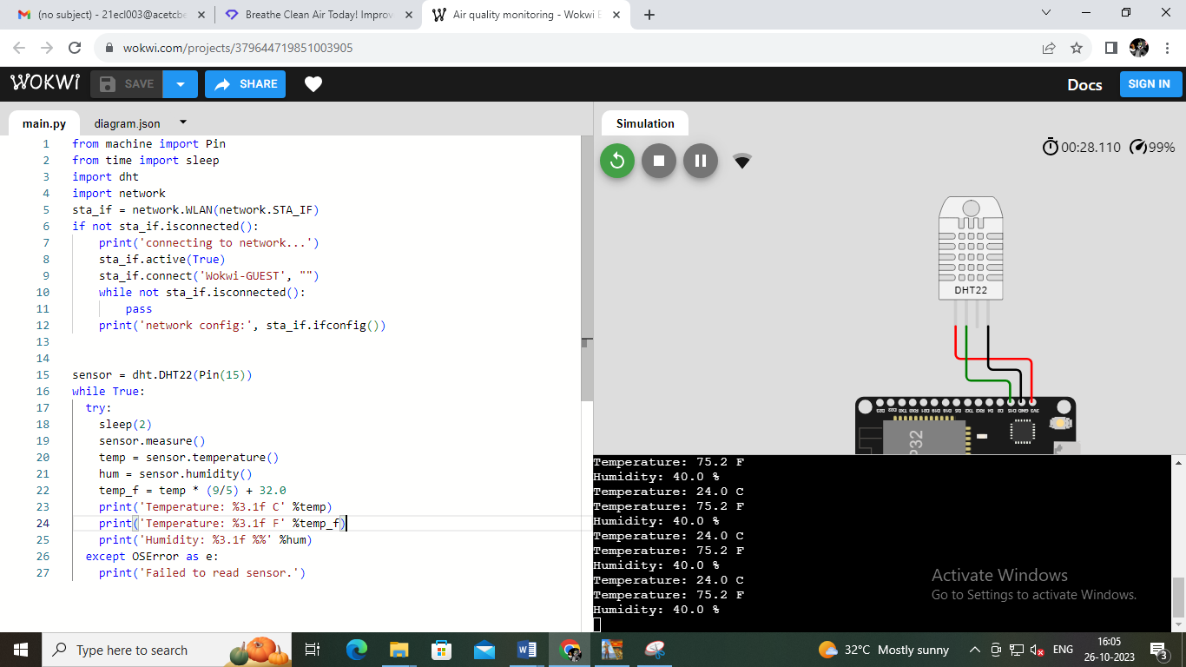

AQI Level AQI Range

Good 0 – 50

Moderate 51 – 100

Unhealthy 101 – 150

Unhealthy for

Strong People 151 – 200

Hazardous 201+

WEBSITE URL

<https://airqualitymonitoringsystem.mydurable.com/>

